Task 4 Output

Hog, k=5

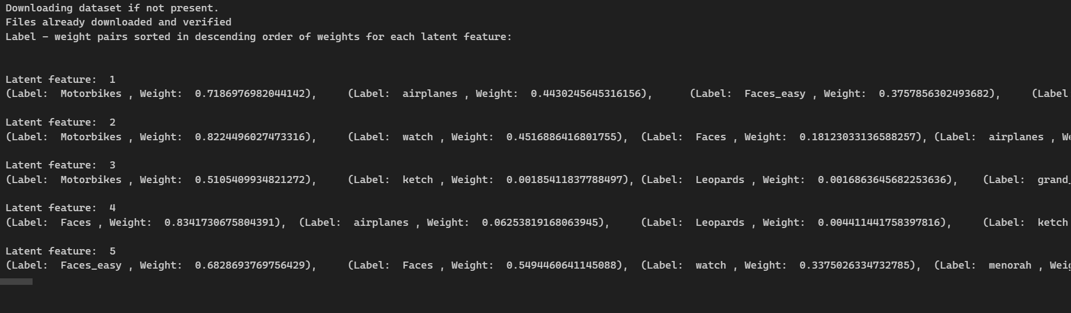

Resnet, k = 5

